Brothen Matthew

Java 2 – Unit 1

14_01

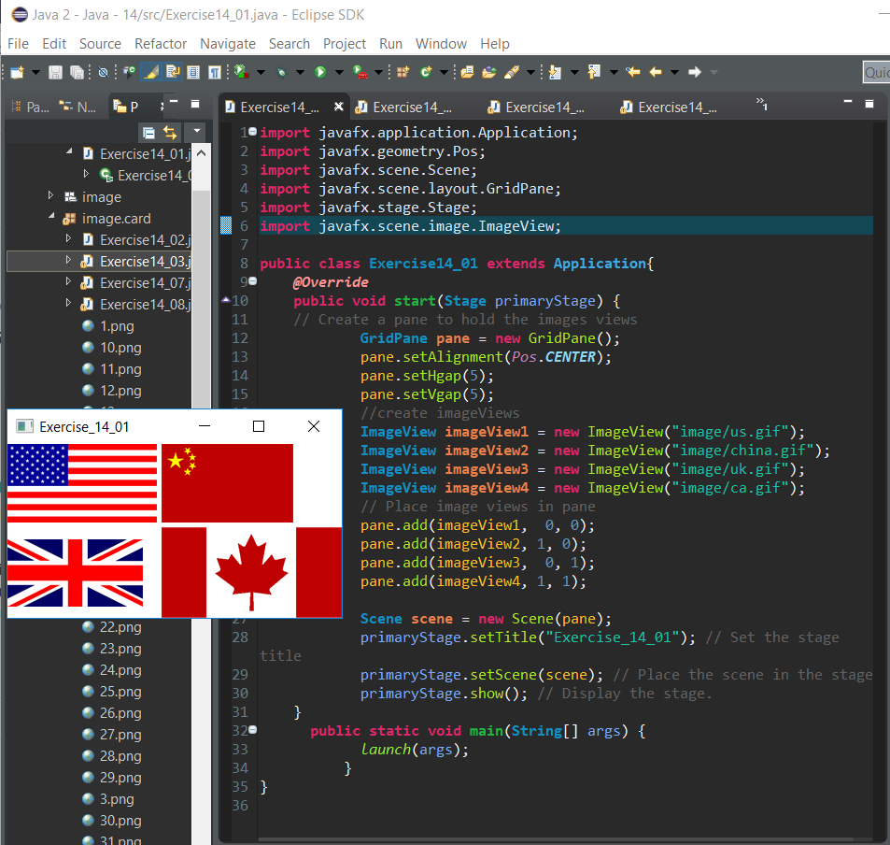

4 flag images in a grid

14_02

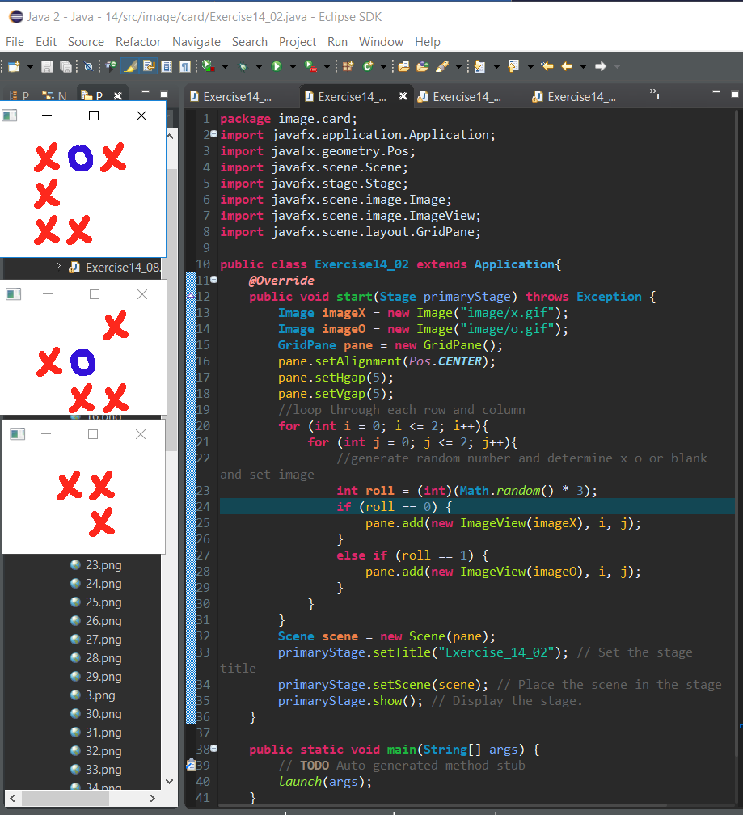

Randomly generated tic tac toe board

14_03

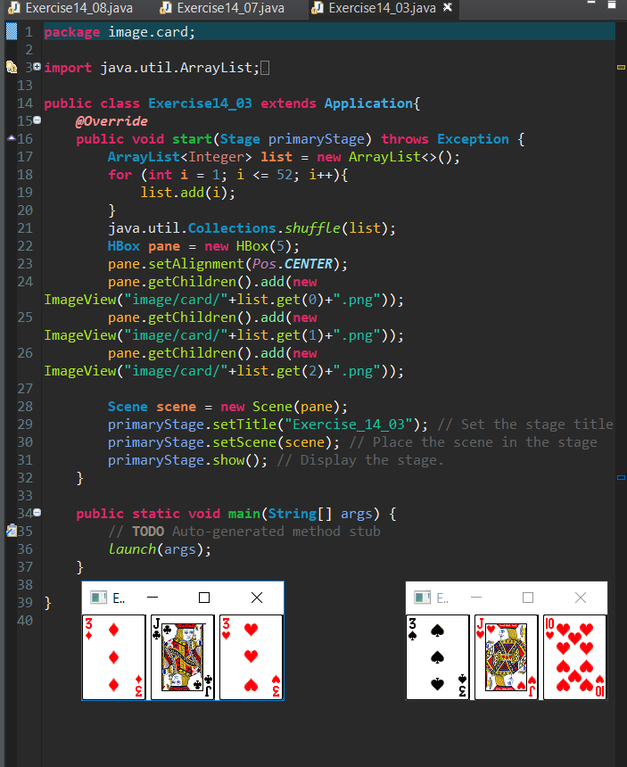

3 shuffled cards using get child

14_07

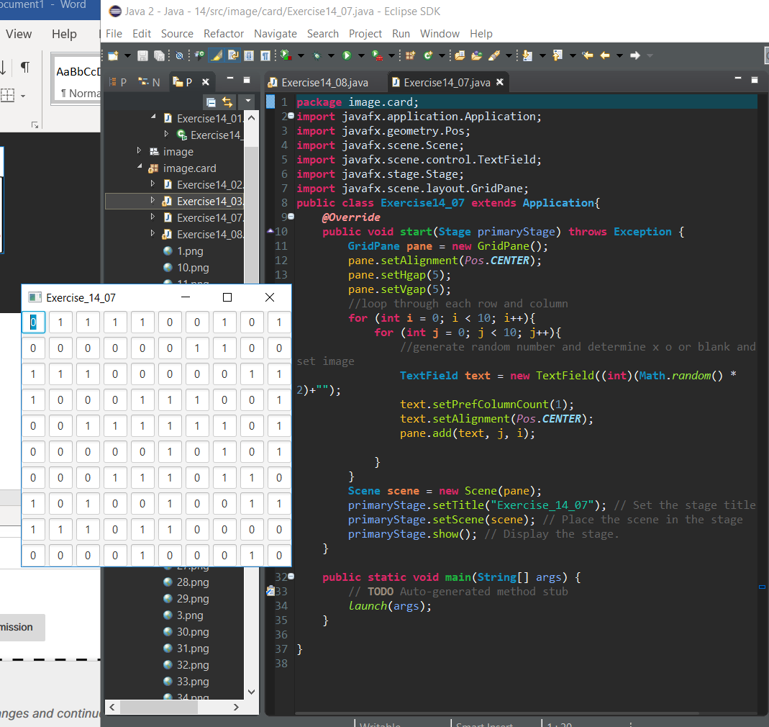

10x10 grid of text boxes with random 1 and 0s filled in each

14_08

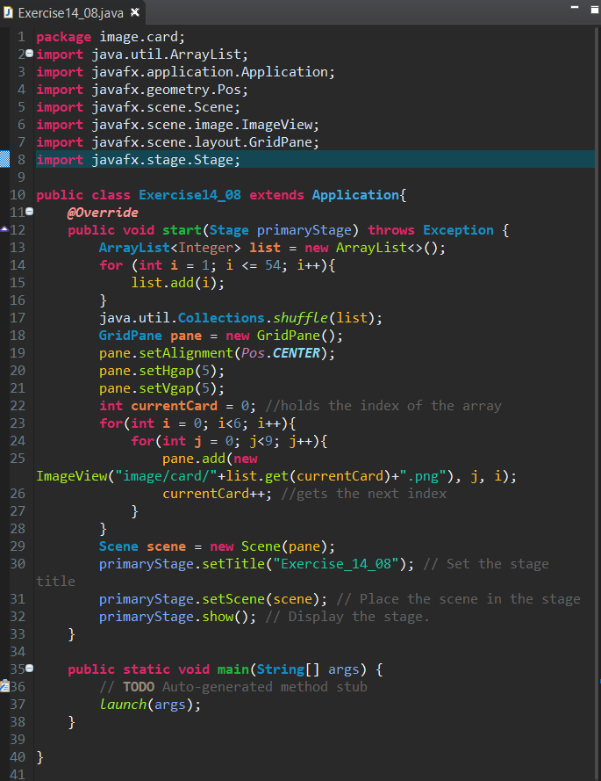

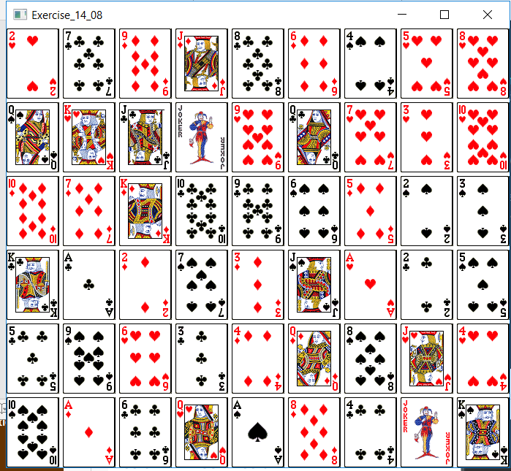

9X6 grid of playing cards, cards in random order.

I attempted to do the assignments before watching the lectures, I couldn’t figure out why if my class extends the Application class that the ide won’t run the application main first. A bit of googling solved my problem. Also refreshing my project files in the IDE after I copied the image fold to the project was a miss that took some troubleshooting to figure out.